
UNIVERSITY OF BOLTON
BSc COMPUTING
COURSEWORK SUBMISSION FORM
Student/Centre to complete:

SURNAME/FAMILY NAME: SABIR FORENAMES: NAVEED

BOLTON STUDENT ID: 2224755 EMAIL: ns7crt@bolton.ac.uk

DATE OF SUBMISSION: 12 January 2024 @ 16:00

MODULE NO./TITLE: SWE5202 Data Structures and Algorithms

TUTOR’S NAME: Abdul Razak

COURSEWORK TITLE: Portfolio item 4 – Maps, Enums data structures and Serialisation.

Please state if this is your FIRST submission OR REFERRED/DEFERRED submission OR a REPEAT submission?
FIRST

…………………..…………………………………………………………………………………………
Declaration
I hereby declare that this work is my own work. I understand that if I am suspected of plagiarism or another form of cheating, my work be referred to Academic Registrar and/or the Board of Examiners, which may result in me being expelled from the programme. I understand once I submit this work, it will automatically belong to the University of Bolton.

Course / Programme: BEng (Hons) in Software Engineering

Module name and code: Data Structures and Algorithms
SWE5202

Tutor: Abdul Razak

Assessment number: 4

Assessment title: Maps, Enums data structures and Serialisation

Weighting 25%

Issue date: W/C 11 December 2023

Submission deadline: 12 January 2024 @ 16:00

Figure 1 8
Figure 2 9
Figure 3 10
Figure 4 11
Figure 5 13
Figure 6 14

Contents
Maps, Enums data structures and Serialisation 4
Stage 1 5
Stage 2 8
Stage 3 9
Stage 4 10
Stage 5 11
UML 13
REFERENCES 14

Maps, Enums data structures and Serialisation
Maps, enums, data structures, and serialisation comprise the foundation of programming, producing an elaborate tapestry that underpins software system design (N. Palmer, T. Kielmann and H. Bal, 2008). Maps, as dynamic containers, offer a flexible technique for associating key-value pairs, not only providing rapid data retrieval but also adaptable storage capacity. Enums, short for enumerations, provide a layer of abstraction to code by specifying a limited collection of named values (K. Poongodi and A. K. Sheik Manzoor, 2019). This improves the expressiveness and maintainability of the code. Data structures, which vary from simple arrays to sophisticated trees and linked lists, serve as the fundamental foundation for organising and manipulating data, allowing developers to apply complex algorithms with ease. Serialisation is an important but sometimes overlooked technology that turns complicated objects into byte streams, enabling for seamless data storage or transmission between several settings. These fundamental concepts provide the basis for various programming paradigms, allowing developers to create scalable, maintainable, and resilient software systems. Developers who wish to navigate the complexity of software development while generating robust and adaptable solutions must have a deep understanding of these concepts. (B. Petersen et al., 2017)

Stage 1
Car Class
The Java code for the Car class constructs a serializable class named "Car" that represents information about an automobile, such as its make, model, colour, and the month its tax expires. To facilitate object serialisation, the class implements the Serializable interface. It has a constructor for initialising the car's make, model, and colour, as well as getter and setter methods for accessing and updating the car's characteristics. There are additional techniques to get and set the tax expiry month. The toString function is altered to return a string representation of the Car object, complete with the make, model, colour, and tax expiry month. This class provides a starting point for representing and managing automotive information in a serializable fashion.

Keeper Class
The Java code features a serializable class named "Keeper" that depicts details about the owner of a motor vehicle. The class possesses forename and surname attributes, along with an Address object. The Address class stores information about the keeper's address, encompassing street, town, and postcode details. The Keeper class implements the Serializable interface to facilitate object serialisation. The constructor specifies the keeper's forename, surname, and address. Getter and setter methods are included for retrieving and modifying the forename, surname, and address attributes. The toString method is adapted to provide a string representation of the Keeper object, inclusive of first name, last name, and address information. This class serves as a framework for the serializable representation and management of keeper information.

RegNo Class
The Java code defines a class named "RegNo," which represents a vehicle registration number. This class implements the interfaces Comparable and Serializable, which enable object comparison and serialisation. The registration numbers are lexicographically compared. The registration number is initialised using a constructor, obtained using a getter method, and compared using a compareTo function. The equals and hashCode methods are also altered to ensure proper object equality and hashing. The toString method is also changed to produce a string representation of the RegNo object that includes the registration number. Overall, the purpose of this class is to encapsulate and simplify automobile registration number routines within a Java application.

Address Class
The Java code defines a class called "Address," which represents a serializable object representing an address. The address's street, town, and postcode are all listed in the class. It implements the Serializable interface, which allows it to handle object serialisation. The constructor initialises the address with the specified street, town, and postcode values, and getter and setter methods are provided to access and update these attributes independently. The toString function is altered to return a string representation of the Address object, replete with street, town, and postcode data. This class acts as a template in a Java programme for representing and processing address information in a serializable manner.

Month Class
The Java code constructs an enum called "Month," which represents the months of the year together with their numerical values. Each month is defined as an enum constant, with an integer value supplied to each constant. For example, JANUARY is associated with the number 1, FEBRUARY with 2, and so on, all the way up to DECEMBER, which is associated with the number 12. The private variable "monthValue" in the enum holds the numerical value associated with each month. The constructor assigns a number value to each enum constant, and a getter method, "getMonthValue," returns the numerical value assigned to a certain month. Using meaningful constants and associated numerical values, this enum depicts months in a programme.

DVLA Class
The "DVLA" class is a serializable Java class representing a Driver and Vehicle Licensing Agency. It models a system that maintains information about car registrations and keepers, providing functionality for managing and retrieving relevant data. Here's a brief explanation:
- Serialization Support:
  - The class implements the Serializable interface, allowing instances of the class to be serialized, meaning they can be converted into a byte stream for storage or transmission.
- Data Maps:
  - The class includes two primary data structures: registrationInfoMap (mapping registration numbers to car information) and keeperInfoMap (mapping registration numbers to keeper information).
  - Additionally, it has separate maps (carRegistrations and keeperInfo) that seem to be declared but are not used in the provided code.
- Constructor:
  - The class has a constructor that initializes the registration and keeper information maps as empty HashMaps.
- Data Addition Methods:
  - addCarRegistration: Adds car registration information to the DVLA database.
  - addKeeperInfo: Adds keeper information to the DVLA database.
- Data Display Method:
  - showAllCars: Displays information about all registered cars in the DVLA database.
- Data Retrieval Methods:
  - getRegistrationInfoMap: Retrieves the map of registration numbers to car information.
  - getRegistrationToKeeperMap: Retrieves a mapping of registration numbers to keeper information.
- File I/O Methods:
  - saveWarningReminderDataToFlashDrive: Saves warning and reminder data to a file using object serialization.
  - readWarningReminderDataFromFlashDrive: Reads warning and reminder data from a file using object deserialization.
  - saveDataToFlashDrive: Saves the DVLA data to a file using object serialization.
  - readDataFromFlashDrive: Reads DVLA data from a file using object deserialization.
- Reminder and Warning Generation Methods:
  - getTaxExpirationReminderList: Retrieves a list of keepers for tax expiration reminder in the specified month.
  - getExpiredTaxWarningList: Retrieves a list of keepers for expired tax warning in the specified month.
- Other Methods:
  - printLetters: A helper method to print registration numbers and keepers from a given letter list.
  - getReminderMonths and getWarningMonths: These methods seem to have incorrect recursive calls and may result in a stack overflow.
- Getter and Setter Methods:
- Various getter and setter methods to access or modify different data structures within the class.
- Constants:
- It includes a constant (serialVersionUID) to help with versioning during deserialization.
Overall, the class provides a framework for managing DVLA-related information and offers methods for data manipulation and persistence.

Test001
The "Test001" class is used to demonstrate the capabilities of the DVLA (Driver and Vehicle Licencing Agency) system. The main function generates Address, Keeper, Car, and RegNo instances, which are then added to a DVLA object. Addresses and keepers are provided specific information, and vehicles are allocated tax expiry months. The addCarRegistration and addKeeperInfo methods are used to add car registrations and keeper information to the DVLA object. Finally, the showAllCars function is used to display data about all registered automobiles in the DVLA database. A hands-on demonstration of how the DVLA system stores and displays car registration information is included in this session.

Here is a screenshot from the output of the program.
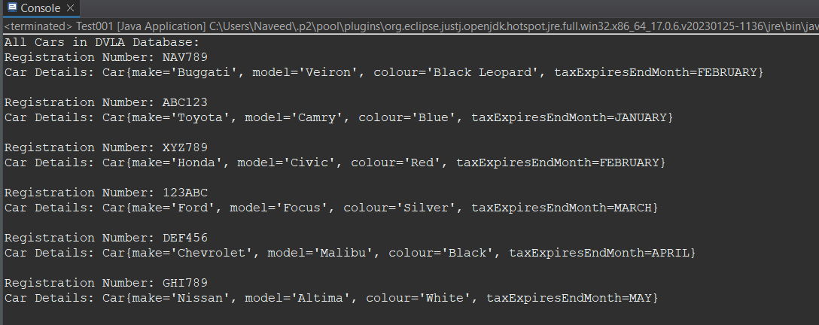
Figure 1

Stage 2
Test002 Class
The "Test002" class serves as a test class to illustrate the functioning of the DVLA (Driver and Vehicle Licencing Agency) system, notably the usage of a TreeMap for sorting automobile registrations based on their registration numbers. In the main method, Address, Keeper, Car, and RegNo instances are generated and added to a DVLA object, identical to the "Test001" class. Furthermore, the DVLA HashMap is transformed to a TreeMap to take use of its key-based sorting capabilities (registration numbers). The sorted TreeMap is then scanned, and information about each registered automobile is presented in sorted order. This class demonstrates the TreeMap's ability to keep a sorted order of automobile registrations and shows a sorted representation of the DVLA database.

Here is a screenshot of the sorted data.

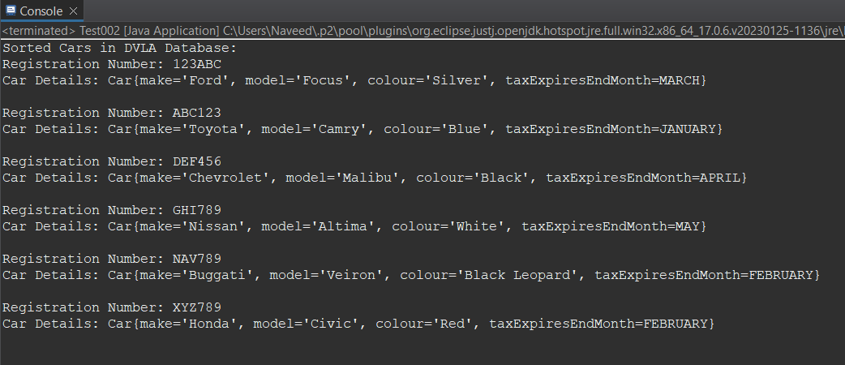
Figure 2

Stage 3
Test003
The "Test003" class serves as a DVLA (Driver and Vehicle Licencing Agency) demonstration class. Identical to the previous test classes, instances of Address, Keeper, Car, and RegNo are produced and assigned to a DVLA object in the main method. The key feature here is the display of registration numbers and corresponding keepers. The DVLA object is used to obtain a map that corresponds to each registration number's owner. The registration numbers and keeper information are then iterated and printed, providing a complete image of the registration numbers and keepers in the DVLA database. This course highlights the DVLA system's ability to record and display keeper information associated with vehicle registrations.

Here is a screenshot of the output.

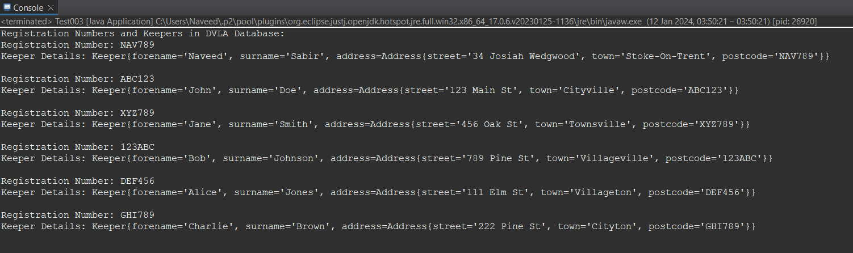
Figure 3

Stage 4
Test004
The "Test004" class acts as a demonstration class for the DVLA (Driver and Vehicle Licencing Agency) system. The purpose of this class is to test the creation of reminder and expired tax warning letters for keepers depending on the tax expiry months of their registered automobiles. In the main method, identical to previous test classes, instances of Address, Keeper, Car, and RegNo are generated and added to a DVLA object.

The test involves assigning tax expiry months to each registered car, followed by the creation of reminder and expired tax notice letters for each month. Two methods are used to get maps that correspond registration numbers with their appropriate keepers for the specified months: getTaxExpirationReminderList and getExpiredTaxWarningList.
The helper method printLetters is used to print the registration numbers, keepers, and the relevant month for both reminder and expired tax warning letters. This lesson shows how the DVLA system may generate and display notifications advising keepers of impending tax expirations (reminders) and expired tax warnings.
Here is a screenshot of the output.
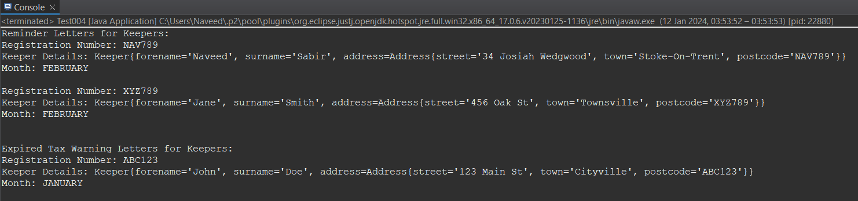
Figure 4

Stage 5
Test005
The "Test005" class serves as a test class to demonstrate the functionality of the DVLA (Driver and Vehicle Licensing Agency) system. Here's a brief explanation of the code:
- DVLA Initialization and Data Creation:
  - A DVLA instance (dvla) is created.
  - Instances of Address, Keeper, Car, and RegNo are created for testing purposes.
  - Cars are assigned tax expiration months.
- Data Addition to DVLA:
  - Car registration information and keeper information are added to the DVLA object.
- Saving Data to a Flash Drive:
  - The data in the DVLA object is saved to a flash drive using the saveDataToFlashDrive method.
- Reading Data from a Flash Drive:
  - The data is then read back from the flash drive using the readDataFromFlashDrive method, and the resulting DVLA object is stored in readDVLA.
- Creating Test Data for Warning and Reminder:
  - Test data for warning and reminder months is created using the getTaxExpirationReminderList and getExpiredTaxWarningList methods.
- Saving Warning and Reminder Data to Flash Drive:
  - The warning and reminder data are saved to a flash drive using the saveWarningReminderDataToFlashDrive method.
- Reading Warning and Reminder Data from Flash Drive:
  - The warning and reminder data are read back from the flash drive using the readWarningReminderDataFromFlashDrive method, and the result is stored in readData.
- Displaying Read Warning and Reminder Data:
  - If the read data is not null, it is displayed, showing warning and reminder information.
- Displaying All Cars from Read DVLA Data:
  - If the read DVLA object is not null, all cars from the read data are displayed using the showAllCars method.
This test class essentially checks the functionality of saving and reading DVLA data to and from a flash drive, and it also tests the warning and reminder data handling.
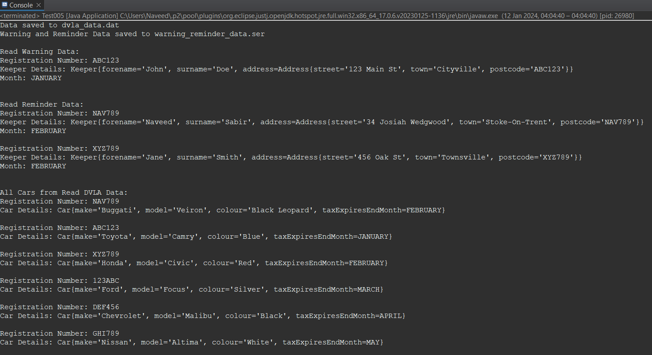
Figure 5

UML

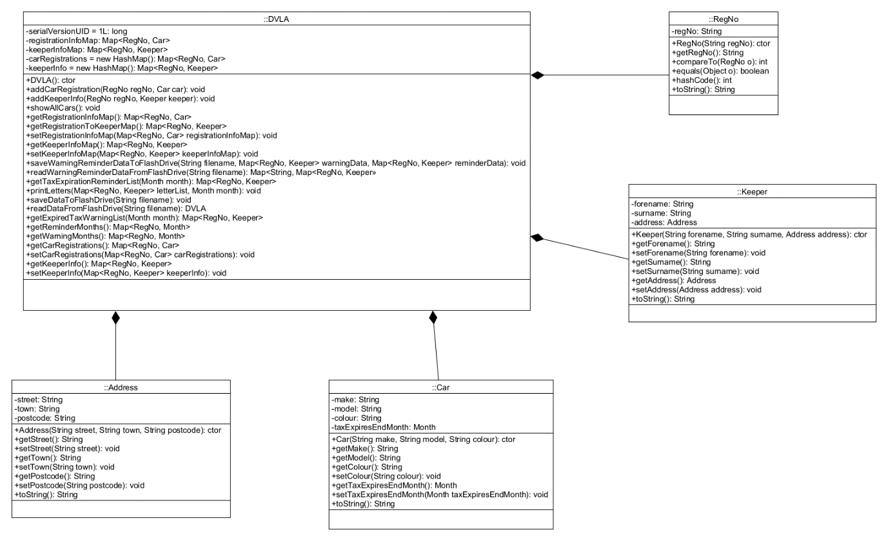
Figure 6

REFERENCES
B. Petersen, H. Bindner, S. You and B. Poulsen (2017) Smart grid serialization comparison: Comparision of serialization for distributed control in the context of the Internet of Things. In:2017 Computing Conference . , [Online] Available from: . [Accessed].
K. Poongodi and A. K. Sheik Manzoor (2019) Mining Entropy Optimized Parameter based Precise positioning Episode Rules from Event Sequences. In:2019 11th International Conference on Advanced Computing (ICoAC) . , [Online] Available from: . [Accessed].
N. Palmer, T. Kielmann and H. Bal (2008) Serialization for Ubiquitous Systems: An Evaluation of High-Performance Techniques on Java Micro Edition. In:2008 The Second International Conference on Mobile Ubiquitous Computing, Systems, Services and Technologies . , [Online] Available from: . [Accessed].

In this assessment I have achieved the following objectives.
Tick appropriate box NA – not attempted: Part – part completed: Full - fully completed | NA | Part | Full
Stage 1 – Creating and populating a HashMap |  |  | x
Stage 2 – Converting a HashMap to a TreeMap |  |  | x
Stage 3 – Registration numbers and keepers |  |  | x
Stage 4 – Month enum and reminder/warning letters |  |  | x
Stage 5 – Serialisation |  |  | x

